Zach Smith
10/7/2025
Network+ Part 1 Practical final

Vlan | Subnet | Usable range | Gateway | Device
Vlan 10 | 192.168.10.0/25 | 192.168.10.1-126 | 192.168.10.1 | Pc a
Vlan 20 | 192.168.10.128/25 | 192.168.10.129-254 | 192.168.10.129 | Pc b
Vlan 99 | 192.168.99.0/24 | 192.168.99.1-254 | 192.168.99.1 | management

For this lab I went with a basic subnetting scheme for hosts and kept the management interfaces on a different subnet.

Successful ping: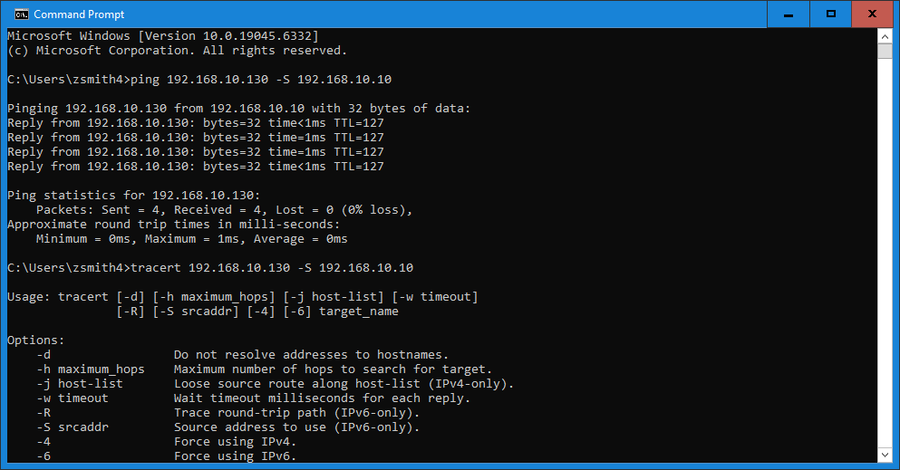

R1 config: 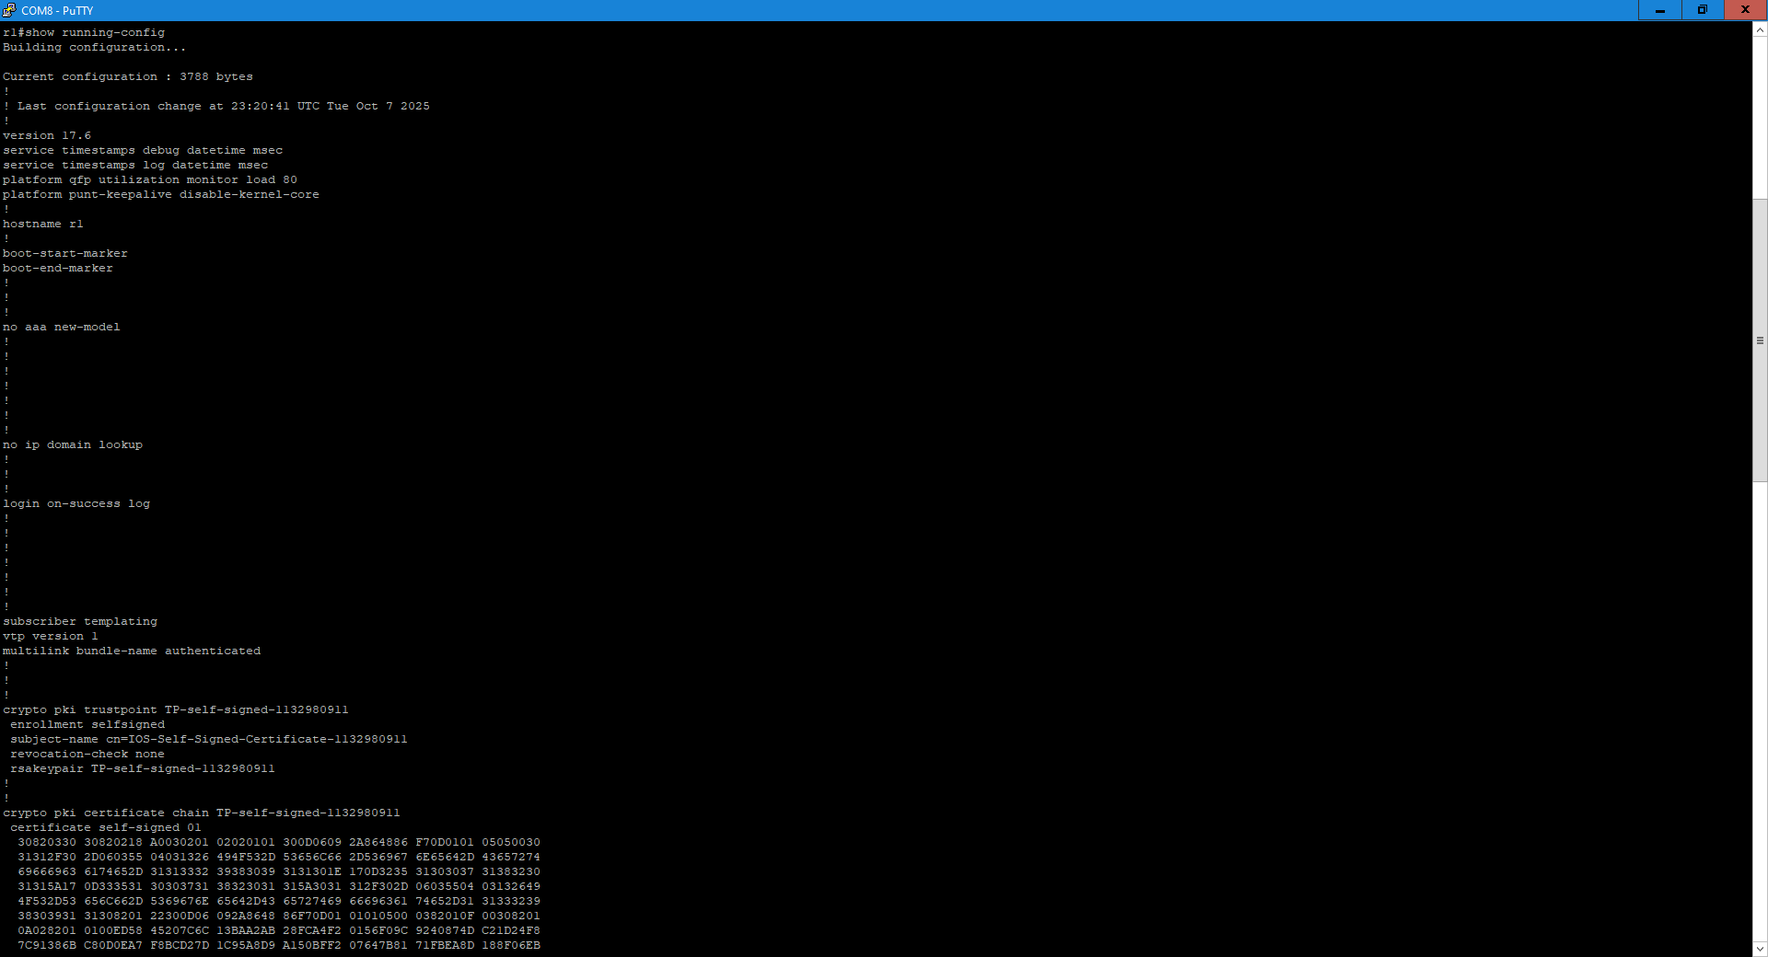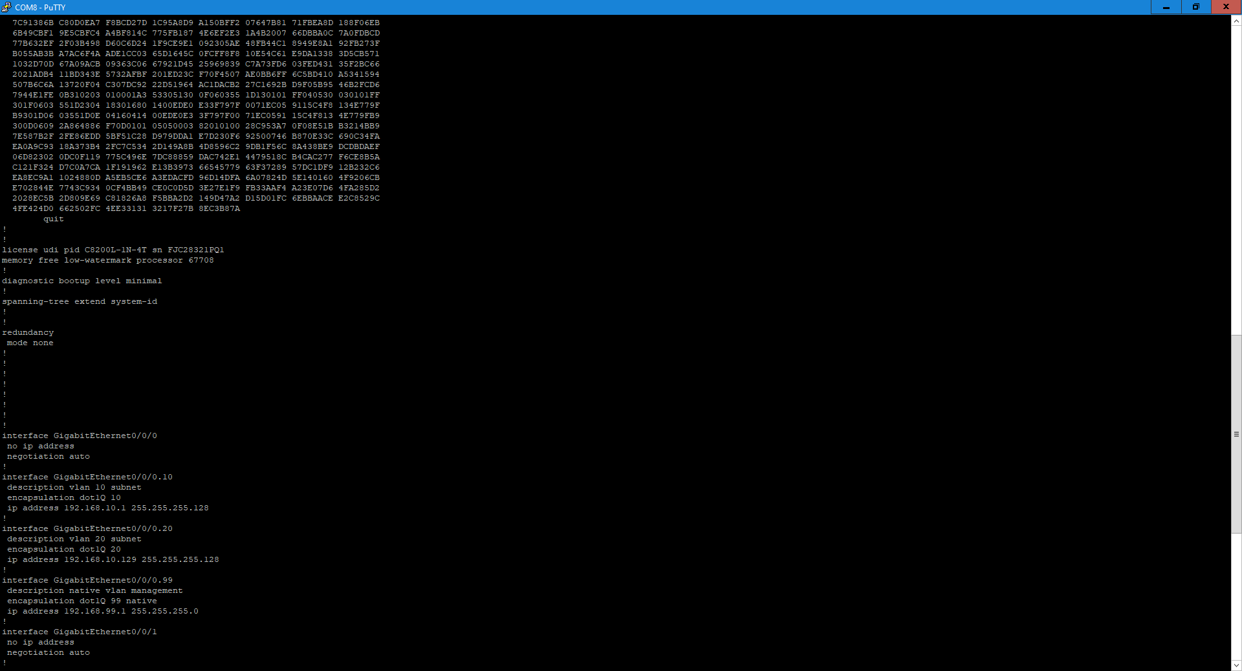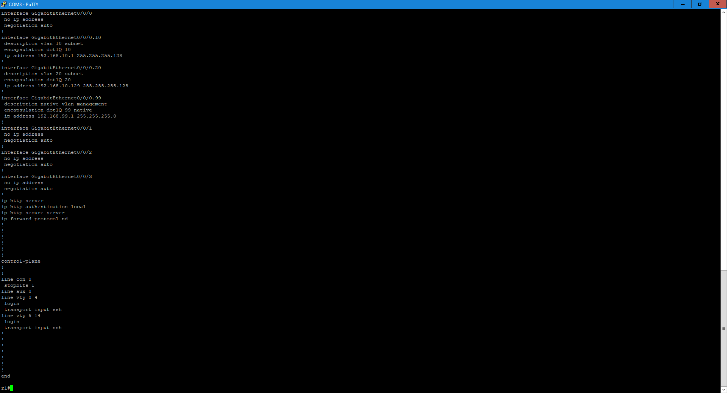

R1 ip interfaces: 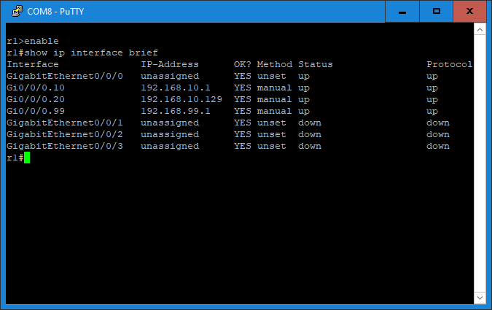

R1 ip route: 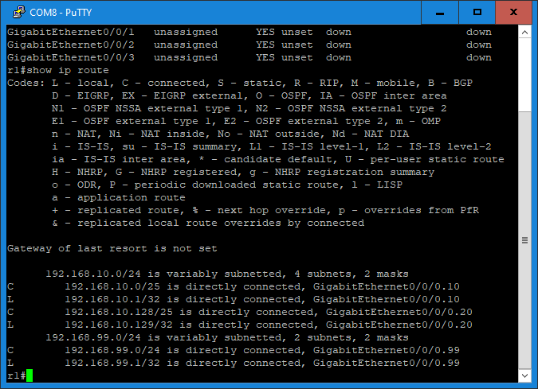

Switch 1 config:
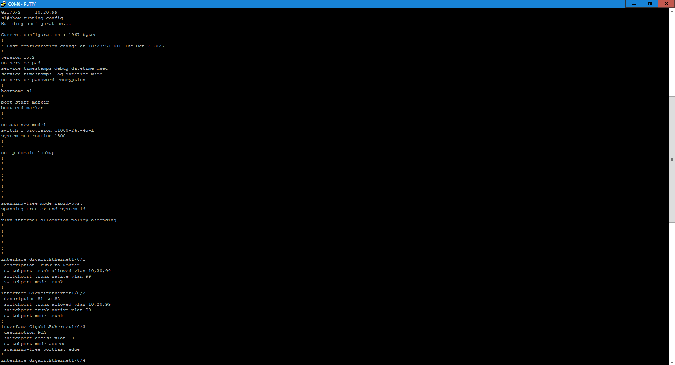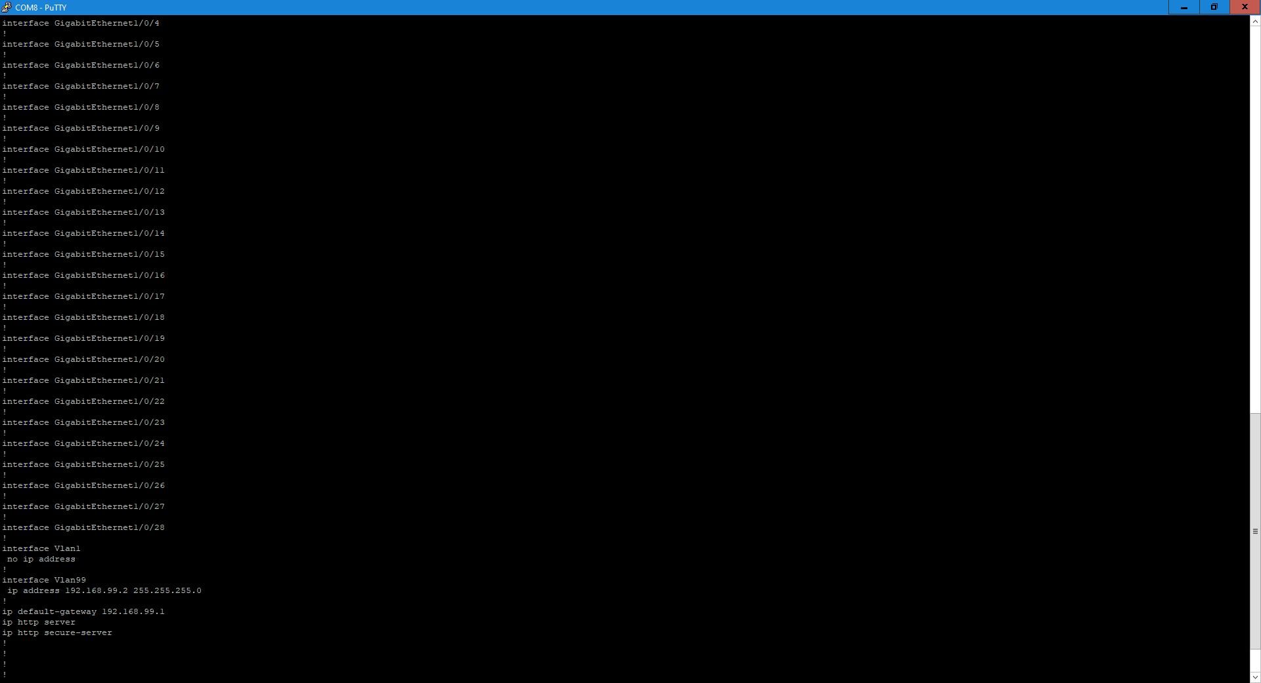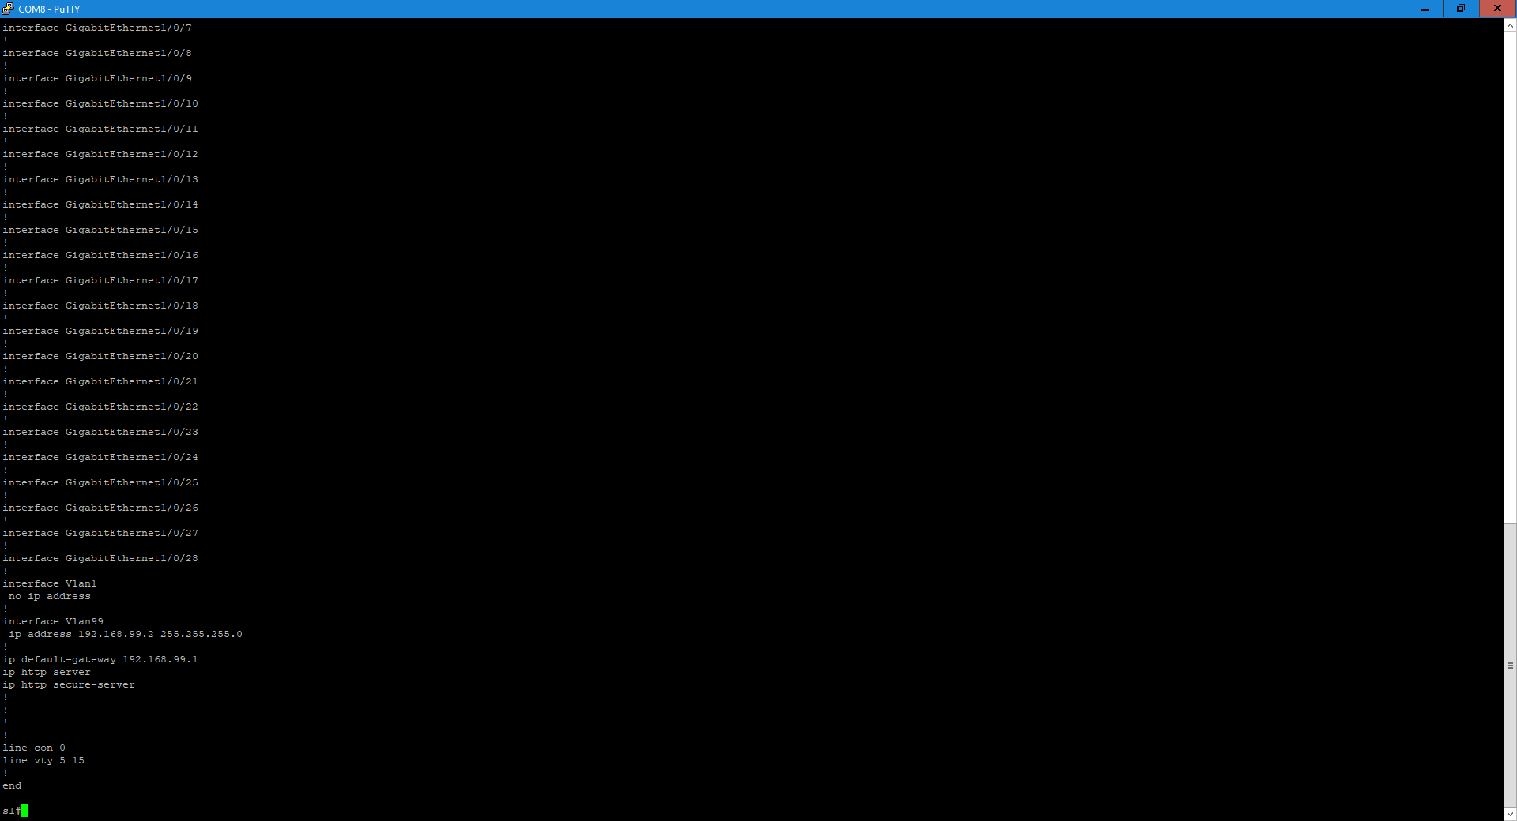

Switch 1 interfaces trunk: 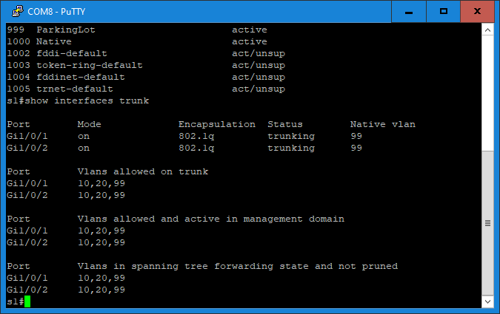

Switch 1 vlans: 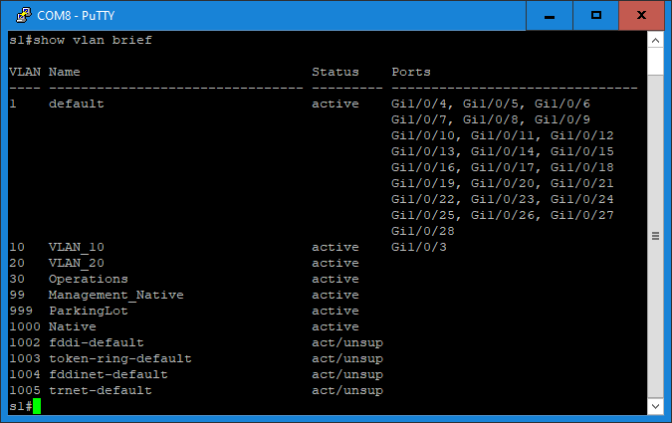

Switch 2 configuration: 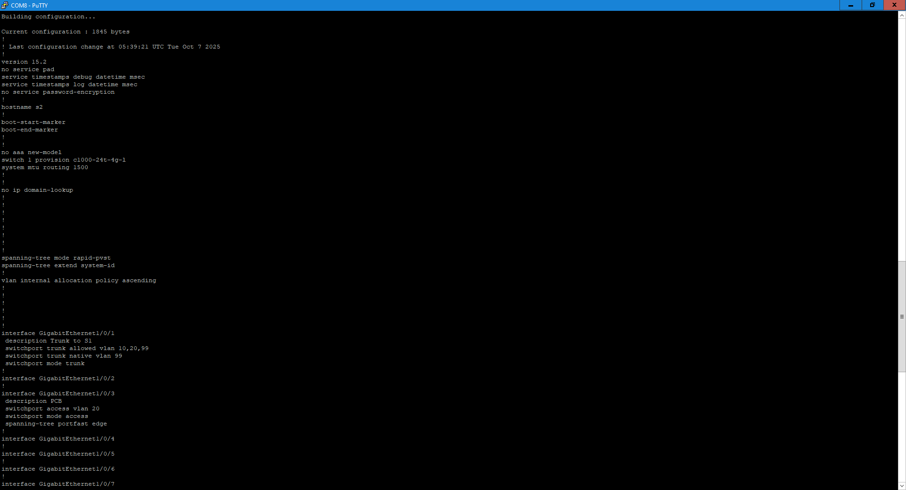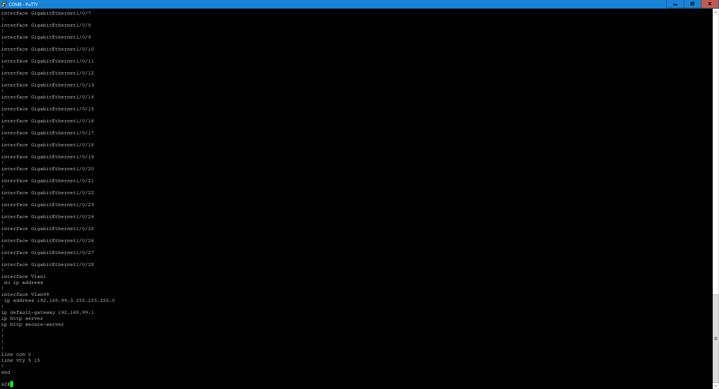

Switch 2 interfaces trunk: 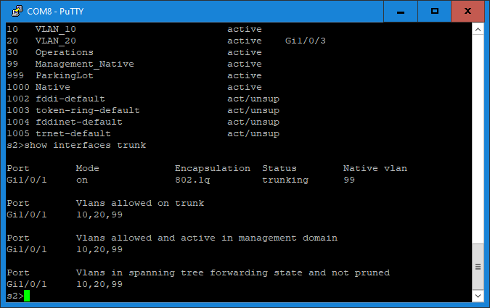

Switch 2 vlans: 